Cherry Yogurt
118 Addison Drive, Tampa, FL
1-800-419-2837
cherrys@cherrysyogurt.com

Table of Contents
I. Executive Summary 04
II. General Company Description 05
2.1 Overview 05
2.2 Legal Description 05
2.3 Company Concept/History 05
2.4 Current Status 05
2.5 Vision & Mission Statement 06
III. Products and Services 07
3.1 Product Description 07
3.2 Service Description 07
IV. Marketing Plan 08
4.1 Industry Overview 08
4.1.1 Marketing Size 09
4.1.2 Target Market 10
4.1.3 Marketing Objectives 10
4.2 Products/Services 12
4.2.1 Pricing Strategy 12
4.2.2 Promotion Strategy 12
4.2.3 Distribution/Placement Strategy 13
4.3 Competitor Analysis 13
4.4 SWOT Analysis 14
4.5 TOWS Strategy Development 15
4.6 Forward Strategy & Future Outlook 16
V. Operational Plan 17
5.1 Production 17
5.2 Location 17
5.3 Inventories 17
5.4 Suppliers 17
5.5 Exit Strategies 17
VI. Management and Organization 18
6.1 Company Structure & Ownership 18
6.2 Core Management Personnel 18
6.3 Roles & Responsibilities 18
6.4 Salary Structure 18
6.5 Key Success Factors 19
VII. Personal Financial Statements 20
7.1 Personal Financial Statements 20
7.2 Details of Personal Financial Statements 21
VIII. Startup Expenses and Capitalization 23
8.1 Capitalization 23
8.2 Startup Expenses 23
IX. Financial Plan 25
9.1 Primary Assumptions 25
9.2 Summary of Financial Results 26
9.3 12 Month Profit/Loss 26
9.4 3 Year Profit Projection 27
9.5 Opening Day Balance Sheet 29
9.6 Break Even Analysis 30
Appendices 32
Appendix 1: Yogurt Shop Values 33
Appendix 2: Pro Forma (Monthly) 34
Appendix 3: Non-Disclosure 35
Research Bibliography 36

I. Executive Summary

The following business plan details the business concept belonging to Mr. John Keats. Mr. Keats has twenty years of military training and experience in the Air Force as a non-commissioned officer. Mr. Keats retired from the Air Force in the Tampa area and decided that he would like to establish his own small enterprise in the area. Mr. Keats recognized that the warm climate through most of the year in Tampa presented a prime opportunity for a self serve frozen yogurt shop to thrive. While the market has some existing ice cream shop operations, it is neither dominated by a single ice cream parlor operator nor by a single self serve frozen yogurt vendor. Thus, Mr. Keats believes that his concept for a self serve frozen yogurt shop in the Tampa area, Cherry’s Frozen Yogurt, is presented with the prime opportunity because of low competitive threat and high market demand. Mr. Keats is requesting a small business loan of $150,000 that will provide the necessary seed money and operating capital while he grows the business. Currently, Cherry’s is in the planning and research phase and is still searching for an ideal location. Mr. Keats is targeting areas near a major freeway, adjacent to a large residential area, and surrounded by existing businesses.

II. General Company Description
2.1 Overview
Cherry’s Yogurt (Cherry’s) is a self serve frozen yogurt parlor concept that is being planned for the Tampa area in Florida. Cherry’s will sell and market a variety of 60 frozen yogurt styles and flavors that are served in cups, cones, and as push-ups. Cherry’s will rotate the 60 flavors and sell 6-8 flavors at a time. All of the store’s yogurts will be displayed in a self-serve dispensing machines at the front of the store that is visible throughout the entire ordering process. The yogurt will be purchased from a quality local vendor in bulk. All employees will wear a casual style uniform consisting of pressed jeans with a polo shirt bearing the store’s logo.

2.2 Legal Description
Yogurt shops operate within the ice cream parlor designation within the US NAICS system. The NAICS number for these operations is 722213 and is described as Snack and Nonalcoholic Beverage Bars.

2.3 Company Concept/History
Cherry’s was conceived of by Mr. John Keats. Having worked in the Tampa area during his stint in the military, he became determined to retire in the area and start a business in Tampa. Following his retirement from the military, Mr. Keats purchased a home in Tampa and took some business courses from the local community college. Mr. Keats recognized from his time during the military in Tampa that the weather is conducive to cold dessert products such as yogurt and ice cream. Since there are already many ice cream parlors, he felt that a self serve frozen yogurt shop provided the best opportunity. Since Tampa experiences fairly warm weather year around, Mr. Keats is certain that such a business holds much promise for success. Although Mr. Keats lacks specific yogurt industry experience, he does have 20 years in the military as a non-commissioned officer responsible for overseeing numerous staff, scheduling, and managing a departmental budget. Mr. Keats believes that this experience combined with his recent academic training provides him with the maximum skills necessary for success.

2.4 Current Status
Cherry’s is currently in the planning stages. While a site address is listed as the location for the store, this is only tentative as no lease has been signed and additional funding has not yet been obtained.

2.5 Vision & Mission Statement
Cherry’s vision statement stresses the company’s sincerity towards ensuring that each guest is treated individually with the intention of having that guest return:

“The relationship with the guest comes before revenues, profits and anything financially oriented.”

Cherry’s mission statement ensures that the company’s staff and its owner never depart from the company’s vision:

“Cherry’s will ensure that each yogurt advertised is in stock and available or the next one is free—all orders will be fulfilled.”

III. Products and Services
3.1 Product Description
Cherry’s will utilize only the highest quality products from the most reputable supplier in the area. Each yogurt product will be of a homemade quality offered by local suppliers to ensure quality and consistency. This not only ensures Cherry’s of the finest yogurt products available, but also ensures its own reputation will be enhanced. Additionally, Cherry’s will also offer a series of both hot and cold drinks to augment its primary product line of frozen yogurt.

3.2 Service Description
The service offered by Cherry’s employees will be unsurpassed in its quality and sincerity. Mr. Keats will institute a thorough training program that emphasizes customer service and satisfaction as much as it does the unique variety of flavored yogurts that the store specializes in. The employees of Cherry’s will be tasked with personally greeting and making eye contact with every customer that enters the establishment as well as in offering small samplers to those who request it. Cherry’s customers will enter the store with the certainty that the store’s yogurt is the best, and they will leave the store with the certainty that they have been treated as if they are valued as customers.

IV. Marketing Plan
4.1 Industry Overview
Yogurt and the frozen yogurt shop is generally classified within the ice cream industry. Therefore, it is useful to examine the industry and market potential from the perspective of the ice cream industry. The ice cream industry’s economic sector is the Snack and Nonalcoholic Beverages Bars coded for NAICS as 722213. The NAICS defines this industry sector in the following manner: “This U.S. industry comprises establishments primarily engaged in (1) preparing and/or serving a specialty snack, such as ice cream, frozen yogurt, cookies, or popcorn or (2) serving nonalcoholic beverages, such as coffee, juices, or sodas for consumption on or near the premises. These establishments may carry and sell a combination of snack, nonalcoholic beverage, and other related products (e.g., coffee beans, mugs, coffee makers) but generally promote and sell a unique snack or nonalcoholic beverage.” The Frozen Yogurt’s industry sector classification is Ice Cream Parlor, which is coded under the NAICS as 7222131 and SIC as 5812. Some industry quick facts are listed below:
- More than 90% of American households consume frozen dessert and related products.
- Some estimates indicate that 60.5% of the frozen dessert market is taken by regular ice cream, 26.2% is for reduced-fat, 5.2% is for frozen ice cream, 4.1% is water ice, 3.5% is sherbet and 0.5% is for other.
- The total U.S. production of frozen dessert and related products in recent years has amounted to about 1.52 billion gallons, or .5 quarts per person. In 2012, the market is forecast to produce 3.5 billion liters of frozen dessert.
- Estimates indicate that home frozen dessert accounted for 70% of the market’s value generating total revenues of $7.2 billion, while impulse frozen dessert purchases made up 14.2% or $1.4 billion.
The frozen dessert industry has two main channels of distribution, retail and wholesale. Typical market segmentation in the global frozen dessert industry, broken down by product, is illustrated in the following table:
The frozen dessert industry’s primary customers are middle to upper income people looking for a convenience product and want to indulge themselves with premium ice cream. Frozen desserts are not products that require the customer to research the product or do price comparison per se, although customers will try different brands. Ice cream is usually bought just on impulse, which is why an ice cream shop’s location is extremely critical. Currently, most yogurt shops are valued from $50,000 to more than $245,000 (see appendix one) which makes a yogurt shop investment potentially quite lucrative. Additionally, seasonality also plays a large role in the consumer’s buying decision since during the winter months less ice cream is consumed. It is important for frozen yogurt shops to have alternate products such as coffee to offset the seasonality unique to the industry if this is not compensated for by other factors such as climate.

4.1.1 Market Size
Globally, the frozen dessert market is viewed as a growth industry and is valued in the billions of dollars. Currently, the global frozen dessert industry is worth $55,369 million with a 4% market growth. The global frozen dessert industry is expected to reach $54 billion by 2015, which is a 22.9% increase. While not directly relevant to the local market, these vast international growth trends in the frozen dessert industry are typically led by the globe’s leading markets such as the U.S. market and these international trends bode well for local yogurt shops that are intent on entering the industry. There are several other international trends and characteristics of the frozen dessert industry, which should be considered in the planning stages of both small and large operations. Globally, the frozen dessert industry segmented into two primary divisions: 1) take-home ice cream which accounts for 39.2% of the market and 2) supermarkets and hypermarkets which account for approximately 34.9% of the total market value. The implication for Cherry’s is that it needs to develop self service bars and take home products, such as take home pints and cakes in order to keep profitable.

Nationally, the frozen dessert industry and market is one of the world’s largest and most vibrant albeit Europe remains the world’s largest market for frozen desserts by volume and value. The U.S. market for frozen desserts grew by 1.5% in the most recent fiscal period, reaching a value of $10,044 million and is forecast to reach more than $10,853 million by 2015 which is an overall increase of 8.1% over present figures. The U.S. frozen dessert market mirrors the segmentation and distribution characteristics of the broader international frozen dessert market. The U.S. market for frozen dessert products expanded over the last five years with a compound annual growth rate (CAGR) of approximately 1.7% as the following chart
Illustrates.

It is apparent that the U.S. frozen dessert market is on a growth trend and the current emphasis on fun, premium and healthy products only makes this trend more promising for Cherry’s.

The U.S. market also mirrors the international ice cream market in its segmentation where take-home products dominate the industry. The U.S. take-home frozen dessert products maintain a 67.7% share of the market and the overall segmentation of the ice cream market by product classification is outlined below:

4.1.2 Target Market
Thus, it is certain that the U.S. frozen dessert market is on somewhat of a growth trend. The current emphasis on fun, healthy products only makes this trend more promising for organic based ice cream products, which allow customers to satisfy their urges for delicious frozen dessert products in which they create without compromising their diet or health concerns. The U.S. market also mirrors the international frozen dessert market in its segmentation where take-home products dominate the industry. The U.S. take-home frozen dessert products maintain a 67.7% share of the market and the overall segmentation of the frozen dessert market by product classification is outlined in the chart above in which frozen yogurt accounts for 8.7% of the frozen dessert market. Cherry’s unique product format and healthy yogurt materials ensure that the enterprise can compete within the impulse and artisan ice cream segments. But, because of the sheer size of the take-home market, Cherry’s simply cannot ignore developing distribution channels such as the self serve concept and relationships with other businesses that can form unique marketing alliances for its products.

4.1.3 Marketing Objectives
Cherry’s will adhere to the following marketing objectives in designing its ongoing marketing and sales strategies:
- To bring in at least 800 people with each promotion
- Have 1,000 individuals sign up for its customer loyalty program the first 12 months of operations
- To meet first year sales projections for both revenue and product unit sales
Sales are forecast to exceed $300k the first year of operations based on forecasted demand. The following sales forecast provides the basis for Cherry’s marketing objectives:
SALES FORECAST
SALES | Year 1 | Year 2 | Year 3
RATIO % | 0.0% | 23.0% | 50.0%
Self serve cone yogurt | $67,200 | $82,656 | $123,984
Self serve small cup yogurt | $43,200 | $53,136 | $79,704
Self serve medium cup yogurt | $30,000 | $36,900 | $55,350
Self serve large cup yogurt | $43,200 | $53,136 | $79,704
Popsicle yogurt | $86,400 | $106,272 | $159,408
Snacks | $36,000 | $44,280 | $66,420
TOTAL SALES | $306,000 | $376,380 | $564,570
DIRECT COST OF SALES | Year 1 | Year 2 | Year 3
RATIO % | 0.0% | 10.0% | 40.0%
Cone yogurt | $28,800 | $31,680 | $44,352
Small cup yogurt | $14,400 | $15,840 | $22,176
Medium cup yogurt | $6,000 | $6,600 | $9,240
Large cup yogurt | $14,400 | $15,840 | $22,176
Popsicle yogurt | $21,600 | $23,760 | $33,264
Snacks | $7,200 | $7,920 | $11,088
SUB/DIRECT COST OF SALES | $92,400 | $101,640 | $142,296
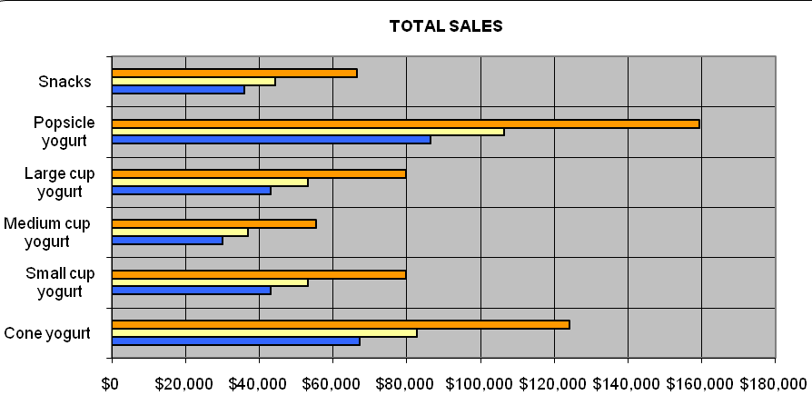

4.2 Products/Services
Cherry’s will purchase the highest quality frozen yogurt products from a local provider. Cherry’s will sell and market both regular yogurts, as well as low fat yogurt products. Additionally, Cherry’s will have the most flavors of any yogurt vendor in the area.

4.2.1 Pricing Strategy
The following table details Cherry’s initial price menu. Prices are subject to change dependent upon suppliers and market events, and are based on an average of the various serving sizes and/or portions:

Cherry’s Pricing Schedule
Yogurt cones | $2.25
Yogurt cups | $2.35
Coffee by the cup | $1.25
Snack products | $3.00

4.2.2 Promotion Strategy
Cherry’s will focus its initial marketing campaign on developing strong word of mouth advertising through a variety of initial marketing activities designed to create marketing buzz:

Grand Opening: The grand opening will last a week and will consist of a press release to the local radio stations and newspapers. Additionally, Cherry’s will offer a $500 give-a-way, as well as a host of printed t-shirts for patrons who enter the location.
Customer Loyalty Program. Cherry's will provide customer loyalty cards to every patron that will be stamped each time a purchase is made. The customers will receive a frozen yogurt cone on their sixth visit. The customer loyalty program will provide Cherry’s in gaining regular customers who tend to spend more in-store when redeeming free-product cards in the same manner that gift cards in other retail outlets generate higher sales. There will also be a location on the customer loyalty card where the customer can fill out his or her email address.

Promotional Budget
Newspaper Advertisements | $6,000
Store Signage | $1,000
Grand Opening | $1,500
Public Relations (give-a-ways/samples) | $500
Total Budget | $9,000

4.2.3 Distribution/Placement Strategy
The distribution of Cherry’s products will take place entirely from the single location that is selected for the operations site. This site will be at a site located centrally in the Tampa area that is close to the major freeways, near a major residential area, and adjacent to existing businesses.

4.3 Competitor Analysis

The frozen dessert industry in the U.S. is highly competitive but is dominated largely by multi-million dollar manufacturers that produce ice cream products primarily for retail distribution in supermarket/hypermarket distribution and there are virtually no mass producers of gelato products. The following table illustrates the market division among the largest frozen dessert market segments within the U.S. market:

The following competitor analysis examines the primary national competitor for an operation of Cherry’s size. Although Cherry’s is a small operation with a single location, it is competing against large national competitors rather than established localized competitors in the Tampa area, which is not dominated by a single frozen yogurt operator or even a single dominant frozen dessert operator:

Pinkberry’s
Strengths:

- Pinkberry has a recently established brand identity based on healthy frozen yogurt products comprised of both traditional and novel flavors such as green tea.
- Pinkberry is founded on a modern or industrial design concept that is conducive to customer retention.

Weaknesses:
- Pinkberry is still relatively small although its franchise format has spurred rapid growth.
- Pinkberry does not focus on the concept of self service, limiting its growth potential by not marketing to a younger consumer.
- The company is limiting its own franchise growth as its website states that it is not currently accepting franchise applications.

Indirect competition for the yogurt industry would be desserts served at restaurants such as pies, cakes and Italian pastries.

Competitor Profile Matrix (CPM) |  | Cherry’s |  | Pinkberry
CRITICAL SUCCESS FACTORS | WEIGHT | RATING | SCORE | RATING | SCORE
Advertising | 0.20 | 3 | 0.60 | 4 | 0.80
Product Quality | 0.10 | 4 | 0.40 | 3 | 0.30
Price Competitiveness | 0.10 | 3 | 0.30 | 2 | 0.20
Management | 0.10 | 4 | 0.40 | 2 | 0.20
Financial Position | 0.15 | 2 | 0.30 | 4 | 0.60
Customer Loyalty | 0.10 | 2 | 0.20 | 3 | 0.30
Brand Identity | 0.20 | 2 | 0.40 | 4 | 0.80
Market Share | 0.05 | 1 | 0.05 | 4 | 0.20
TOTAL | 1.00 |  | 2.65 |  | 3.40

4.4 SWOT Analysis
Cherry’s primary market strengths are its focus on frozen yogurt products rather than attempting to establish itself in several major product lines. By focusing on a single primary product line, Cherry’s is offering itself the most opportunity for success.

The primary weakness for Cherry’s is its relative lack of market experience on the part of its owner and manager, Mr. Keats. While Mr. Keats has years of managerial experience, as well as human resource management skills, he lacks direct industry experience. This creates a potentially hazardous difficulty for him and his business should the market become more competitive over time.

The primary opportunity for Cherry’s is the fact that Florida is a hot weather climate virtually year around. Although it does cool down in the winter months, this season is fairly short. Even during the winter months, it is not uncommon to see days with temperatures in the 60s and 70s in terms of degrees Fahrenheit.

Additional opportunities are present by focusing on the self serve concept. Self serve frozen yogurt shops are becoming a huge trend, allowing younger consumers to indulge in a healthy treat while having fun creating their own specialized dessert. This aspect alone will give Cherry’s a competitive edge over other yogurt shops.

Seasonality is a large threat in the ice cream and frozen yogurt industry, as during the winter month’s retail ice cream shop sales tend to drop considerably. While it is believed that the weather in Florida will shield Cherry’s from this seasonality to some degree, there is a threat that it will negatively impact sales. The other primary threat to Cherry’s ongoing viability is the low-carbohydrate or low-fat trend in some segments of the market. Current health trends indicate that while some market segments are increasingly willing to pay for premium products, others are increasingly monitoring their carbohydrate and fat intake. If Cherry’s does not emphasize the use of its low fat yogurt products in all of its advertising and marketing collateral, it runs the risk of alienating its market.
4.5 TOWS Strategy Development

The following TOWS matrix (threats, opportunities, weaknesses, strengths) reveals how Cherry’s should base its forward strategies by maximizing strengths to take advantage of opportunities and minimize weaknesses in order to avoid market threats:

TOWS MATRIX | STRENGTHS | WEAKNESSES
OPPORTUNITES | Opportunity: health conscious public/Strength: naturally low fat products | Opportunity: growing population/Weakness: higher product fat content de-emphasized
THREATS | Threats: Increasing obesity rates/Strengths: fulfilling products & health conscious yogurt products | Competitor products & lower price points/Weaknesses: Cherry’s cannot compete on price but must create value in service & quality metrics

4.6 Forward Strategy & Future Outlook
Cherry’s will focus on growing its single location to profitability and use to establish brand recognition over the entire Tampa Bay region by measured revenue targets year on year. These measured growth targets ensure that the quality of service and frozen yogurt never drops, while still supporting the local community and increasing revenues and profits. Current research reveals that the ice cream market should continue expanding in terms of overall value or worth:

This type of project industry growth over the next three to five years, combined with the local population’s projected growth and expansion, indicate that Cherry’s will not only be successful, but that it will be able to establish itself before any serious competitive threat can enter the market and undermine its sales growth strategy.

V. Operational Plan
5.1 Production
Cherry’s will not manufacture its own frozen yogurt products but rather will purchase them from a single local supplier. Thus, its product processes consist of storing, opening, and displaying products, as well as serving them and processing payments. Inventories will be ordered and received bi-weekly in order to avoid inventory buildup and to supply fresh products to Cherry’s patrons.

5.2 Location
Cherry’s has not yet selected a specific location but its location will be located near a large residential area, close to established businesses, and by a major freeway and thoroughfare.

5.3 Inventories
Inventories will consist primarily of supplies related to serving Cherry’s products. These consist of cups, cones, and spoons, as well as storage bins for the product in the display freezers. Additionally, Cherry’s will maintain a 3-day supply of its frozen yogurt products in order to ensure customer satisfaction metrics are maintained. Because the product supplier is local, these inventories can be replenished twice weekly.

5.4 Suppliers
The targeted supplier for the frozen yogurt products is DeConna Ice Cream, located at 4605 North Clark Ave., Tampa, Florida, 33614. DeConna has the production capacity to meet all of Cherry’s potential supply needs.

5.5 Exit Strategies
Cherry’s fully expects to stay operational and financially solvent. However, at times this is not a feasible reality due to market conditions or other unexpected events within the employment services industry. In such circumstances, the company will adhere to several strategies that will allow it to liquidate its business and business assets in a fashion that best suits the particular circumstances:

- Sale of Business to a 3rd party
- Liquidation of assets including industry contacts
- Bankruptcy through Chapter 13
- Simple closure of business

IV. Management and Organization
6.1 Company Structure & Ownership
Cherry’s will be a sole proprietorship owned and managed by Mr. Keats. Additionally, he may seek another outside investor, but this is not absolutely necessary should he receive his funding request in the form of a small business loan.

6.2 Core Management Personnel
Mr. Keats: Cherry’s will be owned and managed by Mr. Keats, who is also the company’s primary source of financial support.

Counter Supervisor: A counter supervisor will be hired in order to do the scheduling and management for the counter personnel and staff.

6.3 Roles & Responsibilities
Mr. Keats: Mr. Keats will handle all supplier and vendor relationships, as well as all the company’s marketing strategy development and alliances.

Counter Supervisor: The counter supervisor will handle all of the scheduling of the part-time counter staff, as well as ongoing human resource issues related to discipline and training.

6.4 Salary Structure
The following table illustrates Cherry’s personnel plan for the first three years of operations:

CHERRY’S PERSONNEL PLAN
YEARS | Year 1 | Year 2 | Year 3
RATIO% | 0% | 20% | 22%
Owner Manager | $18,000 | $21,600 | $25,920
Counter Supervisor | $10,800 | $12,960 | $15,552
Part-time staff | $7,200 | $8,640 | $10,368
Part-time staff | $7,800 | $9,360 | $11,232
Seasonal staff | $16,800 | $20,160 | $24,192
TOTAL PERSONNEL | 6 | 7 | 9
TOTAL PAYROLL | $60,600 | $72,720 | $87,264

6.5 Key Success Factors
The following key success factors are critical to the company’s ongoing and long-term success in its industry:

- Hiring talented and innovative employees to fill key roles within the organization
- Maintaining a strict adherence to the company’s vision and mission statements
- Attaining first year sales objectives
- Meeting the company’s three year revenue projection
- Executing the company’s 12 month expansion strategy

VII. Personal Financial Statements
7.1 Personal Financial Statements
PERSONAL FINANCIAL STATEMENTS

SECTION 1 – INDIVIDUAL INFORMATION (Type or Print) | SECTION 2- OTHER PARTY INFORMATION (Type or Print)
Name | Name
Residence Address | Residence Address
City, State, Zip | City, State, Zip
Position or Occupation | Position or Occupation
Business Name | Business Name
Business Address | Business Address
City, State, Zip | City, State, Zip
Res. Phone Bus. Phone | Res. Phone Bus. Phone

SECTION 3 – STATEMENT OF FINANCIAL CONDITION AS OF _________________________________________, 20___________
ASSETS  (Do not include Assets of doubtful value) | In Dollars  (Omit Cents) |  | Liabilities | In Dollars  (Omit Cents)
Cash on hand and in banks |  |  | Notes payable to banks – secured
U.S. Gov’t & Marketable Securities – see Schedule A |  |  | Notes payable to banks – unsecured
Non-marketable Securities – see Schedule B |  |  | Due to brokers
Securities held by broker in margin accounts |  |  | Amounts payable to others – secured
Restricted or control stocks |  |  | Amounts payable to others - unsecured
Real Estate owned as personal residence  See Schedule C |  |  | Accounts and bills due
Real Estate owned as personal residence  See Schedule C |  |  | Unpaid income taxes and interest
Real Estate owned for investment purposes  See Schedule D (attached) |  |  | Real estate owned as personal residence  Mortgages payable – see Schedule C
Loans receivable |  |  | Real estate owned for investment purposes  mortgages payable – see Schedule D
Automobiles and other personal property
Cash value life insurance – see Schedule E |  |  | Credit card/revolving debt
Other assets – itemize |  |  | Other debts – itemized
 |  |  | TOTAL LIABILITIES
TOTAL ASSETS |  |  | NET WORTH = ASSETS – LIABILITIES
 |  |  | TOTAL LIABILITIES & NET WORTH

SOURCES OF INCOME FOR YEAR ENDED_____________________20______ | PERSONAL INFORMATION
Salary, bonuses & commissions $ | Do you a will? No Yes if yes, name of executor
Dividends | Do you a will? No Yes if yes, name of executor
Net real estate income | Are you a partner or officer in any other venture? If so describe
Other income (Alimony, child support, or separate maintenance
Income need not be revealed if you do not wish to have it considered as a basis for repaying this obligation)
 | Are you obligated to pay alimony child support or separate maintenance payments? If so, describe them
Are any assets pledged other than as described on the schedules?
If so, describe
TOTAL $

CONTINGENT LIABILITIES
Do you have any contingent liabilities? If so, describe them | Income tax settled through (date) ______________________
Do you have any contingent liabilities? If so, describe them | Are you a defendant in any suits or legal actions?
As endorser, co-maker or guarantor $ | Personal bank accounts carried at
On leases or contracts $ | Personal bank accounts carried at
Legal claims $ | Personal bank accounts carried at
Other special debt $ | Have you ever declared bankruptcy, personal or otherwise? If so, describe
Amount of contested income tax liens $

7.2 Details of Personal Financial Statements

SCHEDULE A – U.S. GOVERNMENTS AND MARKETABLE SECURITIES

Number of Shares  of Face Value (Bonds) | Description | In Name Of | Are These  Pledged? | Market Value

SCHEDULE B – NON-MARKETABLE SECURITIES
Number of Shares | Description | In Name Of | Are These  Pledged? | Source of  Value | Value

SCHEDULE C – REAL ESTATE OWNED

Address & Type Of Property | Title In Name Of | % Of  Ownership | Date  Acquired | Cost | Market Value | Mortgage Maturity | Mortgage Amount

SCHEDULE D – LIFE INSURANCE CARRIED, INCLUDING GROUP INSURANCE

Name of  Insurance Company | Owner of Policy | Beneficiary | Face Amount | Policy Loans | Cash Surrender Value

SCHEDULE E – BANKS OR FINANCE COMPANIES WHERE CREDIT HAS BEEN OBTAINED

Name & Address of Lender | Credit In The Name Of | Secured Or Unsecured | Original Date | High Credit | Current Balance

The information contained in this statement is provided for the purpose of obtaining or maintaining a credit account, loan, small business loan or other financial transaction on behalf of the undersigned or persons, firms or corporations in whose behalf the undersigned may either severally or jointly with others, execute a guaranty in the issuer’s favor. Each undersigned understands that the issuer of such financial support is relying on the information provided herein (including the designation made as to ownership of property) in deciding to grant or continue such financial support or oversight as is being requested. Each undersigned represents and warrants that the information provided is true and complete and that the issuer or provider may consider this statement as continuing to be true and correct until a written notice of a change is given to it by the undersigned. The issuer or provider is authorized to make all inquiries deemed necessary to verify the accuracy of the statements made herein, and to determine applicant’s creditworthiness or financial health. Furthermore, the issuer/provider is authorized to answer questions about its financial experience with the undersigned party(s).
Signature (Individual)
S.S. No. Date of Birth
Signature (Other party)
S.S. No. Date of Birth

Date Signed 20

VIII. Startup Expenses and Capitalization
8.1 Capitalization
The company’s capitalization will be provided by Mr. Keats in the form of an initial contribution of $50,000. Additionally, Mr. Keats will contribute $10,000 to be held in abeyance should the business environment cause Cherry’s to require additional infusions of capital in order to remain solvent.

8.2 Startup Expenses
The following table illustrates Cherry’s startup expenses and cost projections to opening:

CHERRY’S START-UP EXPENSES
BUSINESS START YEAR | Year 1
OFFICE SUPPLY/PAPER/FAX PAPER/PRINTER INKS | $473
MARKETING/WEB/BUSINESS CARDS/BROCHURES/ADS | $1,305
EQUIPMENT/POS/HARDWARE/SOFTWARE/PHONES/DESK | $3,580
ARCHITECTURE/DECORATION/REMODELING | $2,143
OTHERS-LEGAL (PERMITS/TRADEMARKS/CORPS) | $870
RENT+SECURITY DEPOSIT | $1,500
INSURANCE | $300
OTHER A | $4,100
OTHER B | $700
OTHER C | $2,500
OTHER D | $1,000
FRANCHISE FEE (none) | $0
BUSINESS FEE TRANSFER | $0
TOTAL START-UP EXPENSES | ($18,471)
Start-up Assets Needed
Cash Balance on Starting Date | $8,700
Start-up Inventory | $6,079
Other Current Assets | $1,000
TOTAL CURRENT ASSETS | $15,779
Long-term Assets | $10,000
TOTAL ASSETS | $25,779
Total Requirements | $7,308
Funding & Investor
INVESTOR 1 | $30,000
INVESTOR 2 | $0
OWNER 1 | $0
OWNER 2 | $0
BANK 1 | $0
BANK 1 | $0
TOTAL INVESTMENT | $30,000
Current Liabilities
Accounts Payable | $1,000
Current Borrowing | $0
Other Current Liabilities | $0
CURRENT LIABILITIES | $1,000
Long-term Liabilities | $3,444
TOTAL LIABILITIES | $3,444
LOSS AT START-UP | $18,471
TOTAL CAPITAL | $11,529
TOTAL CAPITAL & LIABILITIES | $14,973

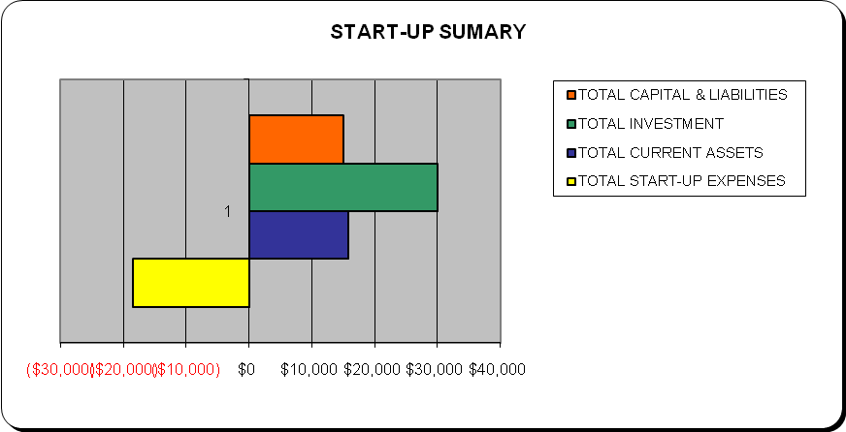

IX. Financial Plan
9.1 Primary Assumptions
Cash Sales: Projected gross sales will be based on the average of the monthly revenues of overall sales.

Other Income: This income is generated through the provision of frozen yogurt and related products.

Cost of Goods Sold: This figure is based on a figure of 35% of revenues, which is the industry corporate standard.

Payroll: This figure is based on the full-time owner-manager position, the counter supervisor and the part-time staff.

CHERRY’S GENERAL ASSUMPTIONS
 | Year 1 | Year 2 | Year 3
Plan Month | 1 | 2 | 3
Current Interest Rate | 10.00% | 10.00% | 10.00%
Long-term Interest Rate | 10.00% | 10.00% | 10.00%
Tax Rate | 25.42% | 25.00% | 25.42%
Sales on Credit % | 50.00% | 15.00% | 15.00%
Payroll taxes | 12.00% | 12.00% | 12.00%
Inventory turnover | 20.00% | 20.00% | 20.00%

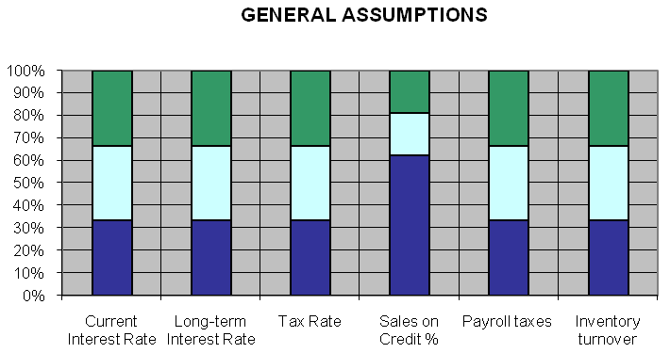

9.2 Summary of Financial Results
1st Year Sales | Net Income | Cost of Sales | 2nd Year Sales | 3rd Year Sales
$306,000 | $106,447 | $92,400 | $376,380 | $564,570

9.3 3-Year Profit/Loss
This table details Cherry’s expected profit and loss through the first three years of operations:

CHERRY’S SALES | $306,000 | $376,380 | $564,570
Direct Cost of Sales | $92,400 | $101,640 | $142,296
Other | $0 | $0 | $0
TOTAL COST OF SALES | $92,400 | $101,640 | $142,296
Gross Margin | $213,600 | $274,740 | $422,274
Gross Margin % | 231.17% | 270.31% | 296.76%
EXPENSES:
PAYROLL | $60,600 | $72,720 | $87,264
Sales and Marketing and Other Expenses | $3,000 | $0 | $0
Depreciation | $0 | $0 | $0
Leased Equipment | $0 | $0 | $0
Utilities | $0 | $0 | $0
Insurance | $0 | $0 | $0
Rent | $0 | $0 | $0
Payroll Taxes | $7,272 | $8,726 | $10,472
Other | $0 | $0 | $0
TOTAL OPERATING EXPENSES | $70,872 | $81,446 | $97,736
Profit Before Interest and Taxes | $142,728 | $193,294 | $324,538
Interest Expense | 344 | 344 | 344
Taxes Incurred | $35,937 | $47,979 | $82,153
NET PROFIT | $106,447 | $144,970 | $242,041
NET PROFIT/SALES | 34.79% | 38.52% | 42.87%

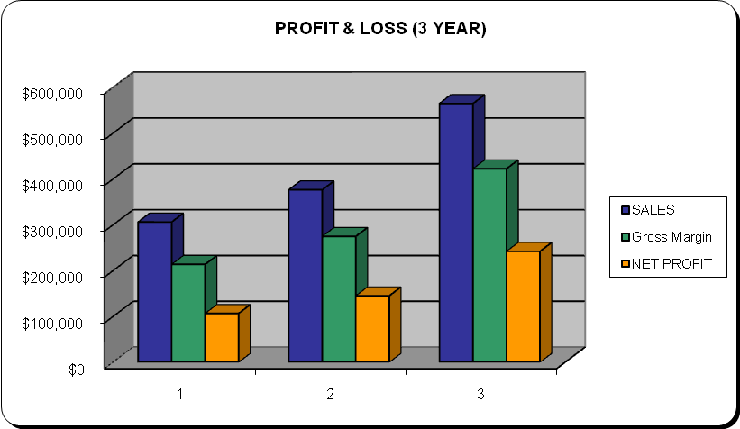

9.4 3 Year Profit Projection
The following table outlines the expected pro forma cash flows through the first three years of operations at Cherry’s:

PRO FORMA CASH FLOW
CASH FROM OPERATIONS | Year 1 | Year 2 | Year 3
Cash Sales | $153,000 | $319,923 | $479,885
Cash from Receivables | $153,000 | $56,457 | $84,686
SUBTOTAL CASH FROM OPERATIONS | $306,000 | $376,380 | $564,570
Additional Cash Received
Sales Tax, VAT, HST/GST Received | $0 | $0 | $0
New Current Borrowing | $0 | $0 | $0
New Other Liabilities (interest-free) | $0 | $0 | $0
New Long-term Liabilities | $0 | $0 | $0
Sales of Other Current Assets | $0 | $0 | $0
Sales of Long-term Assets | $0 | $0 | $0
New Investment Received | $30,000 | $20,000 | $22,222
Subtotal Cash Received | $336,000 | $396,380 | $586,792
EXPENDITURES FROM OPERATIONS | Year 1 | Year 2 | Year 3
Cash Spending (+Payroll) | $60,600 | $72,720 | $87,264
Payment of Accounts Payable | $30,000 | $30,000 | $30,000
SUBTOTAL SPENT ON OPERATIONS | $90,600 | $102,720 | $117,264
Additional Cash Spent
Sales Tax, VAT, HST/GST Paid Out | $0 | $0 | $0
Principal Repayment of Current Borrowing | $0 | $0 | $0
Other Liabilities Principal Repayment | $0 | $0 | $0
Long-term Liabilities Principal Repayment | $0 | $0 | $0
Purchase Other Current Assets | $0 | $0 | $0
Purchase Long-term Assets | $0 | $0 | $0
Dividends | $0 | $0 | $0
SUBTOTAL CASH SPENT | $90,600 | $102,720 | $117,264
NET CASH FLOW | $245,400 | $539,060 | $1,008,588
CASH BALANCE | $490,800 | $1,078,120 | $2,262,576

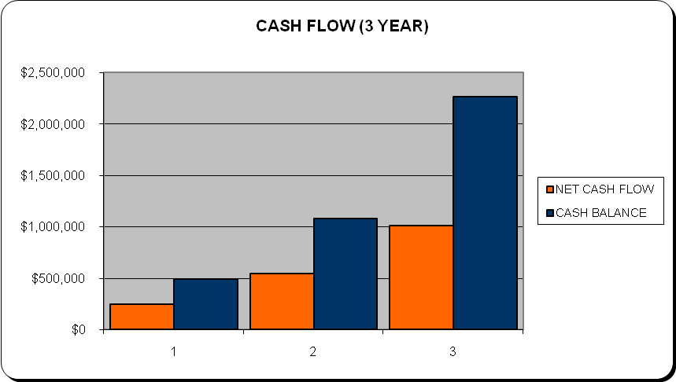

9.5 Opening Day Balance Sheet
The opening day balance sheet is an important metric because it details the financial health of the company upon opening. This detailed information of Cherry’s is outlined below:

CHERRY’S ASSETS | Year 1
Cash | $245,400
Accounts Receivable | $10,000
Inventory | $6,079
Other Current Assets | $1,000
TOTAL CURRENT ASSETS | $262,479
Long-term Assets | $10,000
Accumulated Depreciation of assets | $0
Total Long-term Assets | $10,000
TOTAL ASSETS | $272,479
Liabilities and Capital
CURRENT LIABILITIES | 2008
Accounts Payable | $1,000
Current Borrowing | $0
Other Current Liabilities | $0
SUBTOTAL CURRENT LIABILITIES | $1,000
Long-term Liabilities | $3,444
TOTAL LIABILITIES | $4,444
Paid-in Capital | $30,000
Retained Earnings | $131,588
Earnings | $106,447
Total Capital | $268,035
Total Liabilities and Capital | $272,479
NET WORTH | $268,035

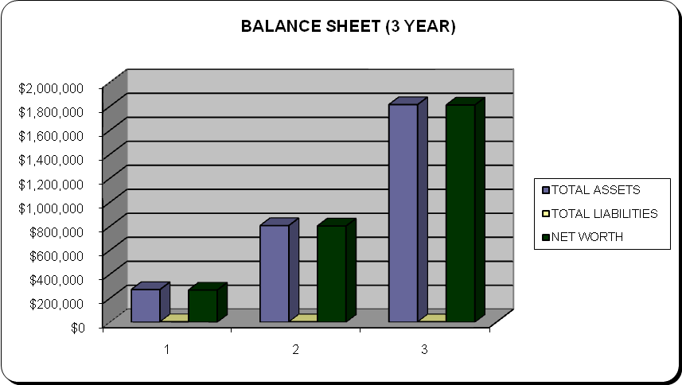

9.6 Break Even Analysis
The breakeven analysis indicates the point at which Cherry’s meets all its necessary expenses and begins to make a profit. This information is detailed below in the following breakeven analysis:

CHERRY’S BREAK-EVEN ANALYSIS:
Monthly Units Break-even | 1,266
Monthly Revenue Break-even | $8,437
ASSUMPTIONS:
Average Per-Unit Revenue | $6.67
Average Per-Unit Variable Cost | $2.00
Estimated Monthly Fixed Cost | $5,906

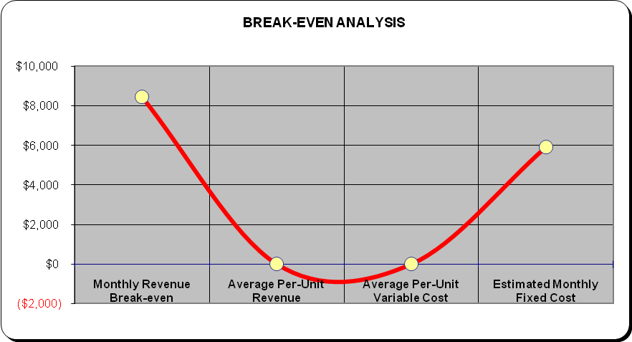

Appendices
Appendix 1: Yogurt Shop Values
Smoothie, Yogurt, Juice Bar Franchise

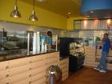 |  | Price: $55,000 | Adj Net: Call/Email | Down: $30,000
 |  | Location: Stevenson Ranch | Area: Los Angeles Area | County: Los Angeles
 |  | Status: Available | Contact: Thomas Nguyen | City: Stevenson Ranch
 |  | Started: 1/27/10 | BizBen Ad#: 131610 | Bkr To Bkr Coop: Yes
 |  | Profile: Solid Residential Base And Office Market Surrounding Site. Motivated Seller.

Smoothie & Self Serve Frozen Yogurt Franchise

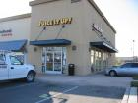 |  | Price: $129,000 | Adj Net: Call/Email | Down: Call
 |  | Location: Inland Empire | Area: Inland Empire | County: Riverside
 |  | Status: Available | Contact: Carol Skinner | City: Lake Elsinore
 |  | Started: 1/12/10 | BizBen Ad#: 138941 | Bkr To Bkr Coop: No
 |  | Profile: Juice It Up! Smoothies & Frozen Yogurt Franchise In Lake Elsinore Marketplace.

Self Serve Frozen Yogurt Franchise

 |  | Price: $245,000 | Adj Net: Call | Down: Call
 |  | Location: West Irvine | Area: Orange County Area | County: Orange
 |  | Status: Available | Contact: Owner | City: Irvine
 |  | Started: 2/8/10 | BizBen Ad#: 136029 | Bkr To Bkr Coop: Yes
 |  | Profile: Popular Franchise, Great Growth, No Fees Or Charges.

(Frozen, 2010)

PRO FORMA PROFIT AND LOSS (P&L)
MONTHS | 1 | 2 | 3 | 4 | 5 | 6 | 7 | 8 | 9 | 10 | 11 | 12
SALES | $25,500 | $25,500 | $25,500 | $25,500 | $25,500 | $25,500 | $25,500 | $25,500 | $25,500 | $25,500 | $25,500 | $25,500
Direct Cost of Sales | $7,700 | $7,700 | $7,700 | $7,700 | $7,700 | $7,700 | $7,700 | $7,700 | $7,700 | $7,700 | $7,700 | $7,700
Other | $0 | $0 | $0 | $0 | $0 | $0 | $0 | $0 | $0 | $0 | $0 | $0
TOTAL COST OF SALES | $7,700 | $7,700 | $7,700 | $7,700 | $7,700 | $7,700 | $7,700 | $7,700 | $7,700 | $7,700 | $7,700 | $7,700
Gross Margin | $17,800 | $17,800 | $17,800 | $17,800 | $17,800 | $17,800 | $17,800 | $17,800 | $17,800 | $17,800 | $17,800 | $17,800
Gross Margin % | 143.26% | 143.26% | 143.26% | 143.26% | 143.26% | 143.26% | 143.26% | 143.26% | 143.26% | 143.26% | 143.26% | 143.26%
EXPENSES
Payroll | $5,600 | $5,000 | $5,000 | $5,000 | $5,000 | $5,000 | $5,000 | $5,000 | $5,000 | $5,000 | $5,000 | $5,000
Sales and Marketing and Other Expenses | $250 | $250 | $250 | $250 | $250 | $250 | $250 | $250 | $250 | $250 | $250 | $250
Depreciation | $0 | $0 | $0 | $0 | $0 | $0 | $0 | $0 | $0 | $0 | $0 | $0
Leased Equipment | $0 | $0 | $0 | $0 | $0 | $0 | $0 | $0 | $0 | $0 | $0 | $0
Utilities | $0 | $0 | $0 | $0 | $0 | $0 | $0 | $0 | $0 | $0 | $0 | $0
Insurance | $0 | $0 | $0 | $0 | $0 | $0 | $0 | $0 | $0 | $0 | $0 | $0
Rent | $0 | $0 | $0 | $0 | $0 | $0 | $0 | $0 | $0 | $0 | $0 | $0
Payroll Taxes | $606 | $606 | $606 | $606 | $606 | $606 | $606 | $606 | $606 | $606 | $606 | $606
Other | $0 | $0 | $0 | $0 | $0 | $0 | $0 | $0 | $0 | $0 | $0 | $0
TOTAL OPERATING EXPENSES | $6,456 | $5,856 | $5,856 | $5,856 | $5,856 | $5,856 | $5,856 | $5,856 | $5,856 | $5,856 | $5,856 | $5,856
Profit Before Interest and Taxes | $11,344 | $11,944 | $11,944 | $11,944 | $11,944 | $11,944 | $11,944 | $11,944 | $11,944 | $11,944 | $11,944 | $11,944
Interest Expense | $0 | $0 | $0 | $0 | $0 | $0 | $0 | $0 | $0 | $0 | $0 | $0
Taxes Incurred | $3,403 | $2,986 | $2,986 | $2,986 | $2,986 | $2,986 | $2,986 | $2,986 | $2,986 | $2,986 | $2,986 | $2,986
NET PROFIT | $7,941 | $8,958 | $8,958 | $8,958 | $8,958 | $8,958 | $8,958 | $8,958 | $8,958 | $8,958 | $8,958 | $8,958
NET PROFIT/SALES | 31.14% | 35.13% | 35.13% | 35.13% | 35.13% | 35.13% | 35.13% | 35.13% | 35.13% | 35.13% | 35.13% | 35.13%
Appendix 2: Pro Forma P&L (Monthly)
Appendix 3: Non-Disclosure Form

NON-DISCLOSURE AGREEMENT

<COMPANY>., and <Person Name>, agrees:

<COMPANY> Corp. may from time to time disclose to <Person Name> certain confidential information or trade secrets generally regarding Business plan and financials of <COMPANY> corp.

<Person Name> agrees that it shall not disclose the information so conveyed, unless in conformity with this agreement. <Person Name> shall limit disclosure to the officers and employees of <Person Name> with a reasonable "need to know" the information, and shall protect the same from disclosure with reasonable diligence.

As to all information which <COMPANY> Corp. claims is confidential, <COMPANY> Corp. shall reduce the same to writing prior to disclosure and shall conspicuously mark the same as "confidential," "not to be disclosed" or with other clear indication of its status. If the information which <COMPANY> Corp. is disclosing is not in written form, for example, a machine or device, <COMPANY> Corp. shall be required prior to or at the same time that the disclosure is made to provide written notice of the secrecy claimed by <COMPANY> Corp.. <Person Name> agrees upon reasonable notice to return the confidential tangible material provided by it by <COMPANY> Corp. upon reasonable request.

The obligation of non-disclosure shall terminate when if any of the following occurs:

(a) The confidential information becomes known to the public without the fault of <Person Name>, or;

(b) The information is disclosed publicly by <COMPANY> Corp., or ;

(c) a period of 12 months passes from the disclosure, or;

(d) the information loses its status as confidential through no fault of <Person Name>.

In any event, the obligation of non-disclosure shall not apply to information which was known to <Person Name> prior to the execution of this agreement.

Dated: _________________

_______________________
<COMPANY> Corp.
_______________________<Person Name>

Research Bibliography
“Barnes Reports: Ice Cream & Frozen Dessert Mfg. Industry (NAICS 31152).” United
States Ice Cream & Frozen Dessert Manufacturing Industry Report, 2011, pp.1-73.
Brankin, Andrea. “Dazbog Coffee to Broaden its Use of Mocapay for Mobile Promotions,
Gift Cards.” CardLine, 11/22(2011), pp.30-30.
“Frozen Yogurt for Sale.” (2010). BIZBEN (online). http://www.bizben.com/business-
types/frozen-yogurt-shops-for-sale.php
“Ice Cream Industry Profile: Global.” (2011). Datamonitor, Dec., 1-45.
“Ice Cream Industry Profile: United States.” (2011). Datamonitor, Dec., 1-41.
“NAICS Definition.” (2012). U.S. Census Bureau. Retrieved from:
http://www.census.gov/ eos/www/naics/ htmls/5/561311.htm
Pinkberry’s Success Story.” Small Business Scene, U.S. News, 05/10.
Reynolds, John. “Calorific Value.” Marketing, 03/16(2011), pp.18-18.

“NAICS Definition.” (2012). U.S. Census Bureau. Retrieved from: http://www.census.gov/ eos/www/naics/ htmls/5/561311.htm
“NAICS Codes and Titles.” (2012). U.S. Census Bureau (online). http://www.census.gov/ epcd/naics02/naicod02.htm
“Ice Cream Industry Profile: Global.” Datamonitor, Dec.(2011): 1-45.
Just the Facts: Frozen dessert Sales and Trends.” International Dairy Foods Association (online). Retrieved from: http://www.idfa.org/resource-center/industry-facts/ice-cream/
“Ice Cream Industry Profile: Global.” (2011). Datamonitor, Dec. 1-45.
“Ice Cream Industry Profile: Global.” (2011). Datamonitor, Dec. 1-45.
“Ice Cream Industry Profile: Global.” Datamonitor, Dec.(2011): 1-45.
“Ice Cream Industry Profile: United States.” Datamonitor, Dec.(2011): 1-41.
“Ice Cream Industry Profile: United States.” Datamonitor, Dec.(2011): 1-41.
“Ice Cream Industry Profile: United States.” Datamonitor, Dec.(2011): 1-41.
“Ice Cream Industry Profile: United States.” Datamonitor, Dec.(2011): 1-41. .
Brankin, Andrea. “Dazbog Coffee to Broaden its Use of Mocapay for Mobile Promotions, Gift Cards.” CardLine, 11/22(2011), pp.30-30.
“Barnes Reports: Ice Cream & Frozen Dessert Mfg. Industry (NAICS 31152).” United States Ice Cream & Frozen Dessert Manufacturing Industry Report, 2011, pp.1-73.
“Pinkberry’s Success Story.” Small Business Scene, U.S. News, 05/10.
“Franchise Information.” Pinkberry Corporate Website. http://www.pinkberry.com/ html/contact_2.php
Reynolds, John. “Calorific Value.” Marketing, 03/16(2011), pp.18-18.
“Ice Cream Industry Profile: United States.” Datamonitor, Dec.(2011): 1-41.

